Summer Childcare 2020

Dear Parents,
In preparation for your 4-week summer session, I am writing with more information about the childcare provision.
BACWTT supports this independent program designed to make your summer weeks easier. This year the main counsellor will be Lily Buller, a graduate of Summerfield Waldorf School, who worked with me last summer. We may, depending on numbers, also have another student assistant.

My goal is to provide a positive Waldorf style camp experience. There will be a healthy balance of games, crafts and activities that appeals to the age range of the children and engages their creativity. We are located at the same campus as the teacher training, Marin Waldorf School. The camp is for children going into Grade 1 in the fall and older. If you have a kindergarten aged child they should be registered in the kindergarten camp hosted by the Marin Waldorf School. This is a licensing requirement. The early childhood camp (“Magic Forest Camp”) is 8.30-5pm. If you require childcare before 8.30 am, please contact me.

I have run the BACWTT camp for a number of years. It is a wonderful opportunity for children from Waldorf schools/homes to get to know others from similar backgrounds, and to be together in a family-style mixed age group. This means that there are lots of friends to play with, younger ones to care for and include and older children to be admired!

The camp is primarily for children of BACWTT students. However, I do sometimes accept other children from Waldorf schools depending on whether including these children will enhance the camp experience. We usually are a group of 10-20 children of mixed ages – grade 1 to grade 6.

The camp opens at 7.45 am. The children are usually keen to see each other even though it is early! We share snack in the morning, which I provide and tailor to the group’s dietary needs. Children must bring a packed lunch and an afternoon snack. After lunch the children listen to a chapter book and have a quiet time. We finish as soon as you possibly can collect the children at 4.30pm. Remember the children have had a long day and so it is helpful if you can postpone any conversations / distractions when you finish your classes at 4.30pm. This allows the counsellors to have a rest / start their commute home after a long and intense day! Please be respectful of the pick up time. You can ask a fellow teacher training student to pick up your child if you are held up.

Please send in your registration as soon as possible – all applications need to be in by March 31 2020. Keep in mind that children who are unwell are best cared for by a parent or well-known family member at home. It is good to give this some thought beforehand, and make a back-up plan.
This is a device-free camp. No ipods, phones or other electronic gadgets. If children wish to bring games, books etc from home to share, please check with me first.

Please find below my contact details, rates and registration form. I check my emails daily and this is the best way to get hold of me. Or text me!

Warmly,

Kate Hammond
2katehammond@gmail.com (707) 481 9132

Summer childcare rates
Deposit required before 1 April 2020

$100 deposit for one child (non-refundable, goes toward total balance)

$50 deposit for each additional child
$40 deposit for Magic Forest children

Weekly rates – these are discounted rates due to the support of BACWTT:

$275/wk for one child

$200/wk for each additional child in the family
$40/wk per child enrolled in Magic Forest Summer Camp

Day rate

$70/day per child (instead of, not in addition to, weekly rates)

The remaining balance is due in full on the first day your child attends camp. Please contact me before April 1 if you wish to spread your payments out.

A mid-morning snack will be provided. Children must bring a packed lunch and afternoon snack.

Lunchtime will coincide with that of the parents so that you have the option of having lunch with your children. If you want to eat with your child, please find a place to eat away from the childcare room, eg. somewhere on the grounds a little removed from the childcare room. This is to support children whose parents elect not to eat with their children.
Summer camp hours are 7:45 am – 4:30 pm. Summer camp operates on the same punctual schedule as teacher training classes. We will be open on July 6.

You will be asked to sign a liability release form and a photo release form on the first day of enrollment.

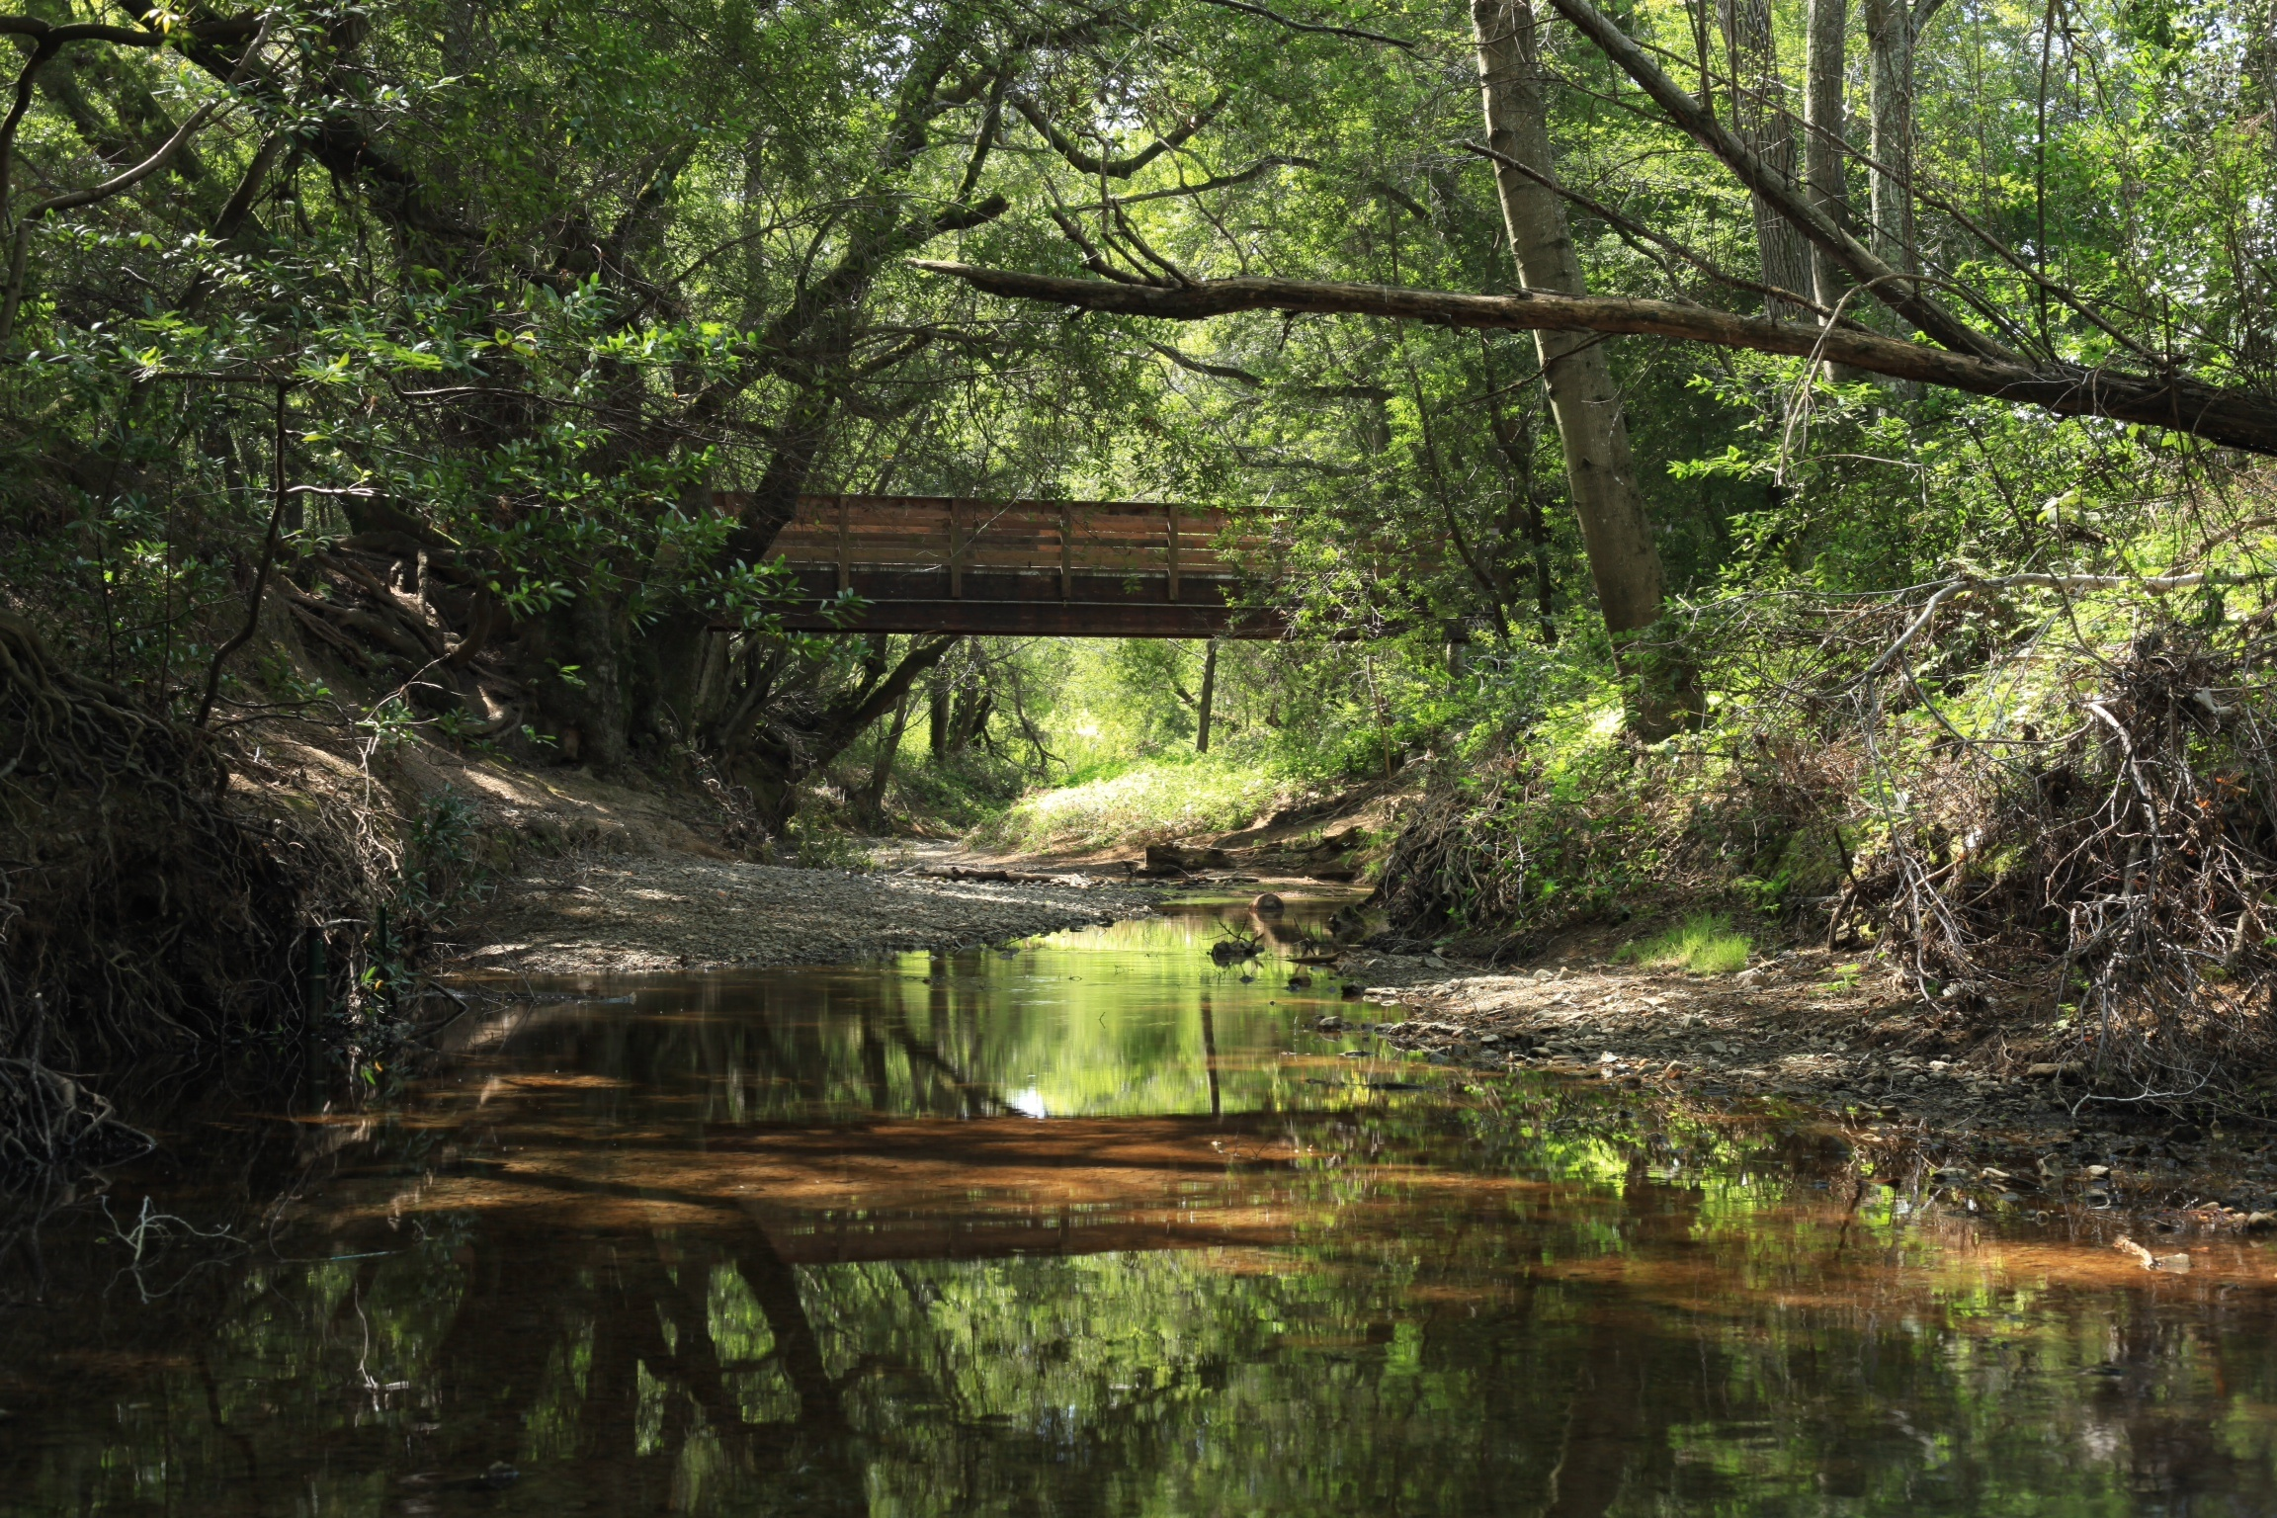
Kate Hammond
5300 Hall Rd
Santa Rosa
CA 95401

Please complete and return the attached form with the appropriate deposit
Checks to Kate Hammond before April 1, 2020, or use
Paypal contact email 2katehammond@gmail.com

Child’s Name: _________________________Age: _____Date of Birth: ________

Child’s Name: _________________________Age: _____Date of Birth: ________

Child’s Name: _________________________Age: _____Date of Birth: ________

Please circle to indicate which week(s) you require childcare

Week 1 (22-26 June) Week 2 (29 June-3 Jul) Magic Forest Camp
Week 3 (6 - 10 July) Week 4 (13-17 July) (early childhood)

Or any other specific days (charged on a daily rate) ________________________

Dietary restrictions, allergies or other medical considerations: ___________________

Parent’s Name: ______________________________________________________________

Address: ____________________________________________________________________

Telephone _________________________________________________________

Parent Name: __________________________ Tel no ___________________________

Instructions in case of emergency ______________________________________

E-mail Address: ____________________________________________________

Deposit enclosed: $ ____________

