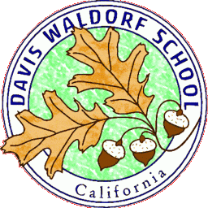
Job Posting for Davis Waldorf School 3100 Sycamore Ln., Davis, CA 95616 Fax: 530-753-0944

Block Teacher – Main Lesson 7th Grade May 2020
We are looking for an experienced Waldorf class teacher to teach a three week Main Lesson block in our 7th grade for three weeks in May. The contents of the block can be arranged with the class teacher who can work her scheduled blocks around teaching preferences.
We are looking for a teacher who has strong communication skills, appreciates teenager and has excellent classroom management skills.
Compensation: $1,800 for a three week Main Lesson block (15 classes, 2 hours per day)
Our school offers a Waldorf curriculum for 1st through 8th grade, a licensed child care center that has two preschools, two Kindergartens and an after school program. We have a strong and experienced faculty dedicated to working out of Anthroposophy. Our parents are invested in their children's education and in the school, bringing great enthusiasm and energy to any project. We are accredited by and a full member school of AWSNA [Association of Waldorf Schools of North America] and WECAN [Waldorf Early Childhood Association of North America].
REQUIRED CERTIFICATES, LICENSES, and REGISTRATIONS: Waldorf teacher training certificate. Bachelor’s Degree. Current TB test results.. Candidate must undergo a Live Scan (fingerprinting) and a background check prior to being hired.
To apply, complete a DWS school application (found on our website, www.daviswaldorf.org, Job Openings), submit your resume, a cover and a list of three references (with e-mail addresses) to the Davis Waldorf School at: recruitment@daviswaldorf.org

